

**Jacquelbot**

**0.9**

# Introduction

Many people enjoy being students of NVC and welcome opportunities to practice using their NVC skillset. An NVC skillset can be practiced at NVC classes, through NVC games, or occasionally through real life emotional issues. Jacquelbot is a new way to practice NVC skills. Students are able to practice NVC skills by interacting with an online chatbot.

Importantly, what separates Jacquelbot from other NVC training tools is that Jacquelbot is capable of objectively scoring the student’s performance. Students can track their scores as they get better at using NVC. Students will be able to interact with Jacquelbot in browser or through their favorite messaging app, like What’sApp or Facebook Messenger.

This is proof of concept to show that using new technologies it is possible to develop tools that enhance NVC skill sets.

# Please Read This Table of Contents.

**Introduction** **1**

**Please Read This Table of Contents.** **2**

Hello Jacquelbot 3

Jacquelbot is designed to play NVC games. 4

Game sessions (called Personas) are easy to create. 4

Every game is an opportunity to learn. So, log everything. 4

NVC is a skillset and a mindset. Games practice the skill sets. 5

**Why Jaquelbot** **5**

Virtual practice produces real life results 6

Business applications of Jaquealbot 7

**Conversational units are the foundation of communication.** **8**

Each conversational unit has a specific communication goal. 10

Conversational units can be linked together. 11

NVC games are modeled with conversational units. 12

**A group of linked conversational units is called a Persona.** **13**

Each Persona is a single training session. 13

A group of Personas form a game. 14

**How to score NVC points in the game.** **17**

Scoring Model #1 - “The Simple Model” (Easy) 17

Scoring Model #2 - “Needs a little empathy”(Medium) 18

Scoring Model #3 - “Emotionally fragile” (Hard) 19

**Persona Development Guide** **23**

A persona is defined in a Google Sheet. 23

Then it is converted to JSON file that the computer reads 24

**Application Technical Architecture** **26**

**Screenshot of current implementation** **27**

## 

## **Hello Jacquelbot**

**THE URL**

The best way to learn Jacquelbot is to play with it.

**Try this link to visit Jacquelbot at htttp://127.0.0.1:5000/ NOT WORKING AT THIS TIME**

**Sample dialog**

Below with Jacqueline who is a persona that is frustrated and hungry.

This dialog was generated by Jacquelbot, but has been shortened for this example,

Jaquelbot

----------------------------------------------------------------------------------------------------------------------------

Background: For this persona, imagine that you have just arrived at the city park, around 11:30am, to take a walk with your old friend. You haven’t spoken for a few weeks, so it is nice to get updates. You know that sometimes your friend can be very opinionated, but strong opinions hide unexpressed feelings and needs.

**You: hello**

**Jacqueline: Hello**

**You: how are you today**

**Jacqueline: Wow, I'm glad that you asked. This town sucks. All the restaurants are bad around here. Everybody knows that!**

**You: are you feeling sad about the restaurants?**

**Jacqueline: Way off. I don't feel sad.**

**You: ok, well then are you feeling frustrated about the restaurants?**

**Jacqueline: Yeah, that’s it I’m feeling frustrated.**

**You: Do you have a need for food, now?**

*More ...*

Following the introduction above, the student is able to communicate to Jacquelbot. The student could be communicating through a browser or phone app.

## **Jacquelbot is designed to play NVC games.**

* **Modular** - Because Jacquelbot is modular. It has the ability to grow quickly in different directions.
* **Persona models** - Each training session (persona) will model a different emotional/need issue.
* **Scoring models** - It will contain 4 scoring models. Plus, it is imagined that additional scoring models can be added to help improve student performance.

## **Game sessions (called Personas) are easy to create.**

* Personas are defined in a spreadsheet.(The data model is below). Each persona allows a very detailed conversation to be created. It currently supports over 250 emotions and 60 needs and growing. It allows an author to be very selective about the word and sentence usage for each stage of the conversation.
* It is imagined that as the library of persona models grow, so will the library for basic conversations. Basic libraries can be shared across many different personas. Here are some examples of basic libraries that could be created and shared.
  1. The current persona models do not contain responses for faux-feelings (abandoned, abused, rejected,...) Once we have created a model for responding to faux-feelings, it can be used across many different personas.
  2. Models for stop words, unnecessary words, could be shared between personas.
  3. We could create a model to handle typical stupid questions to Jacquelbot, like “Do you like nvc?”, Do you have feelings?” or things like that.

## **Every game is an opportunity to learn. So, log everything.**

* It is understood that the best feedback for improvement for Jacquelbot will be the errors from things it does not understand. For example if someone types “I like pizza”, an irrelevant statement, we should be able to see from the logs what the response is and to correct that response in the future. *This is even more important when someone uses NVC in a novel way and Jacquelbot gives a poor response.* We should be able to take that learning and apply it to future sessions. Jacquelbot has detailed logs that capture everything. These logs can later be mined for data.
* We can also use the data in the logs to improve the scoring. For example, we can ask an NVC professional to interact with Jaquealbot, with all interactions being saved to the logs. Then we can use the logs to model that conversation as being a winning score for future students. Students who have conversations similar to the NVC professional will receive a passing score.
* After Jacquelbot is released on the internet, **consider what type of data you would want and we have 100K conversations to evaluate**? Identifying patterns in big data sets, will enable the creation of Jacquelbot responses that can handle most situations.
  1. Most common guessed feelings (so we can create better models)
  2. Most common stupid questions (so we can create better models)
  3. NVC scores for men over 30? (linguistic research)
  4. Identify regional language differences/preferences (linguistic research)
  5. Typical order of pronouns when guessing feelings. (linguistic research)
  6. ...

## **NVC is a skillset and a mindset. Games practice the skill sets.**

NVC is a *skillset* and a *mindset*.

* The ***‘skillset’*** is contains skills to
  + identify of another person’s feelings or needs
  + communicate naturally and gracefully with NVC. (non-violent, non-leading, OFNR,...)
* The ***‘mindset’*** is both
  + a desire for connection and
  + mindfulness, a stable emotional base that provides the foundation of the conversation.

Jacquelbot is designed to be a tool to help develop skillsets. (It is not clear how Jacquelbot can support the development of the correct mindset.)

For the mindset, it is **not** expected for NVC students to try to fake the feeling of connection with the Jacquelbot personas. However, we do hope that NVC students approach Jacquelbot with curiosity appropriate to any new game.

**Realistic expectations of scoring.**

* To create a score for the conversation, a student’s responses will be compared against examples. There are common NVC’ish ways to say things and those patterns can be cataloged for scoring. However there will always be new ways to say something in NVC, that will receive a low score because it does not fit the *current* models well. Developing a large catalog of responses will help mitigate the problem that new responses will be scored poorly.
* Cultural issues will need to be addressed as Jacquelbot is released to different audiences. Even within the United States there are cultural differences, that create communication differences, that might require changes to the persona communication models. For example “y'all’’ (southern) vs. ”you guys” (northern). Regional specific models are expected.
* Most importantly perhaps is our web of experiences that help us form **our own definitions** of the words we use, shaped by family, culture, gender, race, and many other factors

# **Why Jaquelbot**

I want to practice my NVC skills. Practicing with people is very productive, but It can be hard sometimes to practice with others because of the need to schedule focused time for the practice. Further, I had a need for flexibility and convenience. I wanted that ability to have short practice sessions, on short notice. And, I want to be able to pause in the middle of a training session, like I do when I practice with my French language phone app.

With this background, Jacquelbot got started when I was looking at my list of new year's resolutions. One of my resolutions was to create something in 2021: it was going to be either (1) a book on business in the silicon valley or (2) an NVC chatbot. I was torn between which one to do. I gave myself a few weeks to feel and pray for the correct answer. I wanted to be sure of the right choice, because I knew it would be a large investment of my time. Then one day, I went to Linked”In.com. Linked’In has a ‘news feed’, similar to Facebook, and I satisfied my curiosity by scrolling through the news feed. There were several posts about business books in the news feed. And in a moment of mental clarity, it occurred to me, “*Wow, the world doesn’t need another business book*.” Et voila.

## Virtual practice produces real life results

Working with virtual training partners has proven to be effective practice for real life interactions.

<https://neurosciencenews.com/virtual-human-training-18257/>

This article also shows virtual video training partners. Future versions of Jacquelbot may include video training partners.

**Long term vision of Jacquelbot**

The ultimate goal is for building a communication model(s) for evaluating NVC communication that can be reused in different ways in the future. Jacquelbot looks to the future in 2 ways:

1. Create a basic model that can be applied to a large variety of NVC games
   * Can be used to gamify existing NVC games, like WeGROK
2. Create language NVC models that can be reused in future technologies
   * New messaging apps, after WhatsApp or Facebook
   * It can be used in robots that mimic facial expressions for training
   * It can be adapted to voice input rather than text input, in order to practice speaking NVC
   * It can be used in applications for video or robot based training.

## 

## Business applications of Jaquealbot

Because Jacquelbot can capture objective measurements on a person’s NVC communication skill sets, this tool might be valuable to corporations that would like to improve their employee’s communication skills and Emotional Quotient (EQ). Jacquelbot provides the corporation both

(a) a training tool for employees to practice communication skills

(b) an evaluation tool to check employee learning.

A use case might be a company that would like to up-skill their customer service (hot line) team’s communication patterns. Customized personas can be created for particular customer service issues, for interactions with both customers and team mates.

Corporations will have an easy time providing training to employees, since Jacquelbot can be accessed through a browser or through their favorite messaging app, like What’sApp or Facebook Messenger.

These kinds of conversations happen between employees every day.

# 

# **Conversational units are the foundation of communication.**

## 

The basic unit of conversation is the core of Jacquelbot.

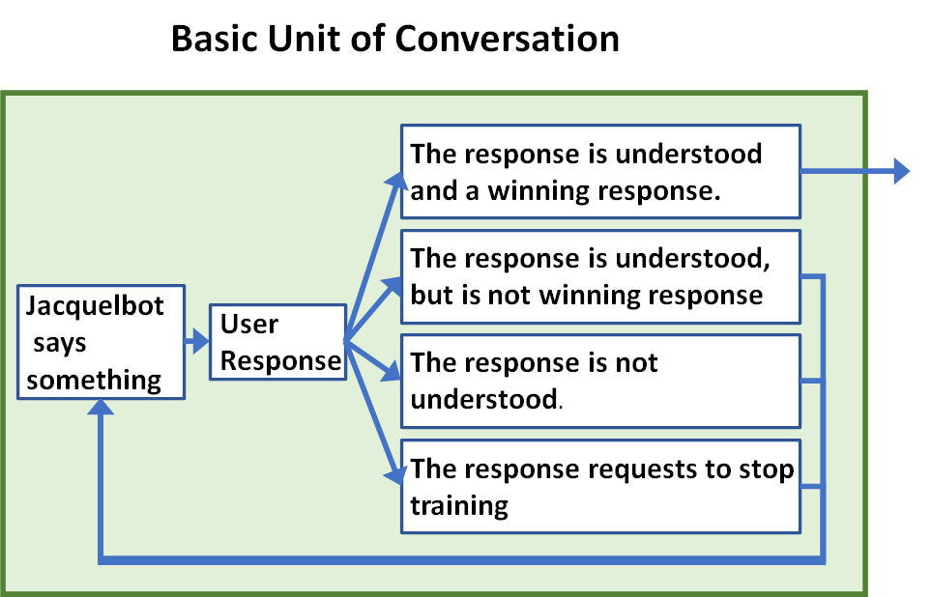

**Details**

Below is a flow chart of the general process. The first step in this model is for the NVC student (User) to check in and to try to find out what is alive in them. Then the NVC student will give a response and it will be evaluated.

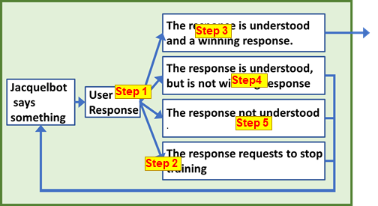

•**Response models** -There is not one model that can handle the complexity of the NVC communication. Several models are needed to be layered together to form a cohesive conversation. For example, when determining the Jaquelbot’s response to the user input, several model-steps are used.

•**Step 1 -** Clean the user input of unnecessary words, also called ‘stop words’. Sentence analysis models often do better if some common stop words are removed like “the” and ”of”. The cleaned sentence is easier to decode the meaning.

•**Step 2** - Check if student_input is like “nvc help” or nvc_feelings”, then form an appropriate response. This can print out a list of feelings or let the student exit the game

•**Step 3** - Check if student_input contains the correct feeling or sentences, based on word frequency analysis. This calculates the similarity between the student input and ‘example_inputs’’ by the number of words that they have in common. We return a response appropriate to the example input with the greatest similarity to the student input..

•**Step 4** – There are two ways that it can be understood

•We can develop training sets for common responses, such as guessing the wrong feeling/need. These responses would be authored inthe persona file.

•If user’s response does not contain a feeling/need but appears to be a well-formed sentence, we can send it to a separate general conversation bot to form an appropriate response. This bot is designed to respond to weird things and to direct the conversation back on target. This bot does not need to be part of the persona file as it can be reused for all personas.

•**Step 5 -** Response not understood- If the response if not understood, Jacquelbot will try to ask the user to clarify

Scoring happens after the response is formed.

## **Each conversational unit has a specific communication goal.**

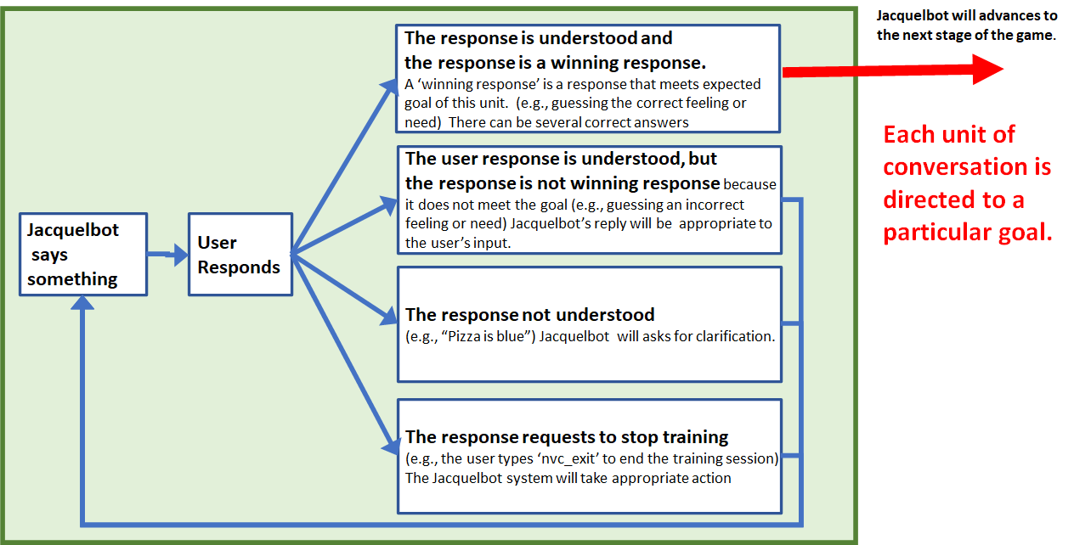

**The “goal of a conversational unit” can be defined several ways in a persona. The goal can be defined by either response based or score based methods**

Response based goals, for example winning responses might be:

* a winning response could be a correctly using a specific word (such as, “happy”)
* Or using a specific phrase (such as, “you feeling sad”)
* Or using a phrase that is semantically similar to an example phrase
* ...

Score based goals, for example winning responses might be:

* A certain amount of total points for guessing the correct feelings (positive for good guesses, and negative for bad guesses)
* Compute the mathematical similarity between two sentences [reference](https://medium.com/@adriensieg/text-similarities-da019229c894)
* After 3 tries just move on to the next thing anyway.
* ...

## 

## **Conversational units can be linked together.**

The typical NVC conversation is often shaped like this::

(1) inquire about the person,

(2) figure out their feelings,

(3) figure out their needs,

(4) look toward strategies.

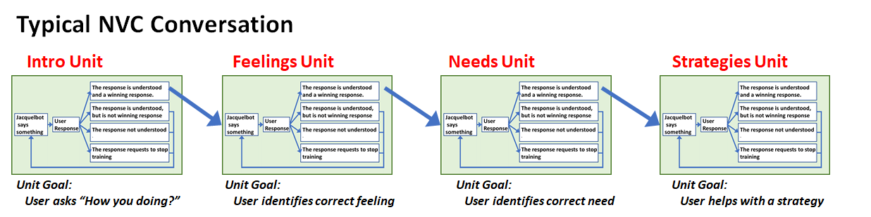

## 

## **NVC games are modeled with conversational units.**

The model for the base version of Jacquelbot is a four step model show below

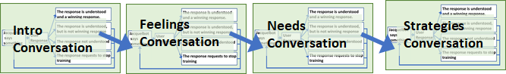

**Jacquelbot can be reconfigured to handle other NVC exercises with little effort.**

For example:

**Games from GROK**

**#1 GROK  
 (get list of feelings, try to guess the needs)**

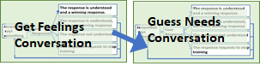

**#3 Practice AngerRRR game**

**(get angry situation , try to guess the needs)**

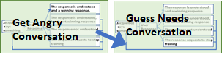

**#8 Practice I might feel that way if**

**(get situation , try to guess feelings)**

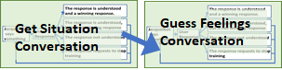

# **A group of linked conversational units is called a Persona.**

## **Each Persona is a single training session.**

When the conversational units are linked together to create a cohesive personality to train with, it is called a persona. A persona is defined by a file that has the information necessary to have the complete conversation across several conversational units.

**1 unit persona**

Enables simple games, like “guess the feeling”, based on certain prompt.

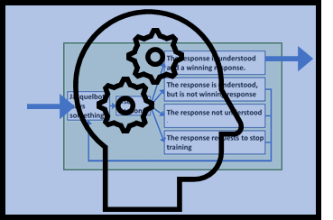

**2 unit persona**

Enables more complex games that guess the feeling and need with 2 different prompts

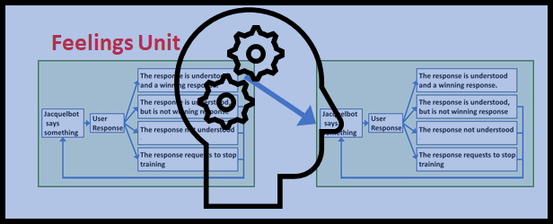

**4 unit pesona**

Enables more complex conversations that have several parts

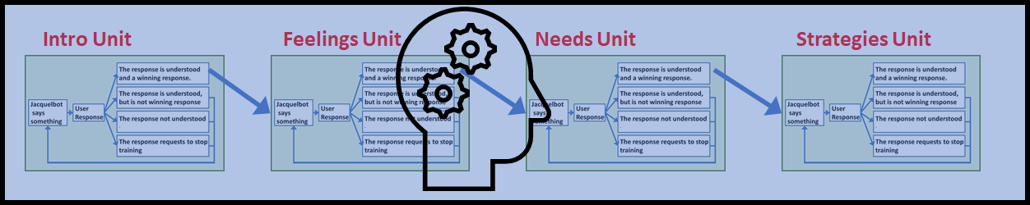

While the initial version of Jacquelbot is designed for the 4 unit persona, it can be customized for other games, if desired.

## **A group of Personas form a game.**

For the Jacquelbot base game, in a typical training session the student will interact with 5-10 different personas, to analyze their feelings and needs.

For the initial version of Jacquelbot, The following tables were used in order to select appropriate personas.

**These feelings and needs demonstrated in these personas were selected because:**

They cover a wide set of emotions

They are common experiences

Three different types of life experiences

| **Type** | **Comments** |
| --- | --- |
| **Friends & Family (adult)** | **These are the typical stories that you would expect for NVC training.** |
| **Children** | **Children have a simpler vocabulary and fewer life experiences. So exercises should use simpler tools and situations. It is assumed that children probably don’t understand the complexities of some adult relationships.** |
| **Business** | **Business situations tend to focus on a different types of feelings and needs than that of Friends and Family.** |

**Information Spoiler Alert:**

**This table below contains the answers to the Jacquelbot base game.**

**Spoiler Alert: This table contains the answers to the initial game**

| **Group** | **Feelings** | **Needs** | **Short Story** | **Long Story** |
| --- | --- | --- | --- | --- |
| *Intro* | *hungry* | *frustrated* | *All the restaurants in this town suck.* | *This example persona teaches the new user how to use the system* |
| Friends & Family | depressed, sad, scared | health, safety | I'm feeling down because I learned I have cancer | Well, I went to the doctor the other day and found out that I have cancer. They think I'll probably survive, but you never know. Like, what does it mean to have a 70% survival rate? Yeah so, I've been thinking about that a lot and doing a lot of reading medical papers. It is uncomfortable to make any long term plans or even just to think about long term plans when things are uncertain. |
| embarrassed | respect, community | I'm sorry that I spilled wine on your carpet. I feel like a failure. | I am such an idiot. Oh, I feel so bad that I spilled my glass of wine on your carpet. I can't beleive how stupid I was. You were being so nice to use by having over for lunch, and making a nice meal, then I wreck everything by spilling wine all over your beautiful carpet. Oh, you probably hate me now |
| frustrated | respect, acknowledgement | I do so much work around the house and nobody acknowledges my efforts. | Honey, we need to talk. I work and work around the house and nobody notices. It is like I some sort of invisible vacuum that is expected to go around and clean up behind people. And I don't so much mind doing it, but it is like no one cares at all. It's like everyday, I see you taking my hard work for granted. I could be doing something else for me, instead of helping around here, but I never get even on little, 'thank you'. |
| nervous, scared | integrity, authenticity | "NVC sucks, don't use that crap on me. | Hey, I know what you are doing. You are going to use that nonviolent communication crap on me, again. You always sound so stupid when try to speak giraffe or rhino, whatever furry animal they call it. You are not going to hear me talking in a fke way like that! I'm going to speak from the heart, exactly how it comes to my head. So the world can see the real me. |
| scared, worried, troubled | order, peace, protection, predictability | The new president is crazy and stupid. | Background: This persona was inspired by communication with an older person with strong political beliefs. Imagine, you and this person are old friends who talk, but sometimes the political conversation can be a little hot. The hot political conversations do not give you the sense of connection that you want with your old friend. Instead you want to use NVC better understand what is alive with your friend.  I'm fine, but you know what bugs me a lot these days? The new President! Biden has canceled the Keystone pipeline and it’s putting 50,000 people out of work and now gas prices have gone up 70 cents. The new president is crazy and stupid. |
| upset | autonomy | Stop telling me what to do, You are so annoying | Stop telling me what to do, You are so annoying. Everyday, you have to give me your opinion on how I should do everything in my life. It drives me crazy. I can be an adult, you know. I don't need you to to tell me what to do all the time. I'm perfectly fine doing crap by myself without you trying take care of things all the time. Just go away. |
| **Group** | **Feelings** | **Needs** | **Short Story** | **Long Story** |
| Child | sad, lonely | connection | I broke my phone | I broke my phone and now I can't talk to anyone. It totally sucks to be me. Dude, I was craving my skateboard, then I tired to land a crooked-grind, but I bailed out and my phone slimed out of my pocket. It kinda boffed hard on the cement. The screen is totally busted, but it won't even turn on. So sad cause I can't talk to any of my bros. I feel all the lines of communication have been cut, and I'm out here skating alone wihtout a phone. |
| happy | fun & play, connection, to be seen | I can't stop jumping up and down about todays' birthday party | I can't stop jumping up and down about todays' birthday party. I go so much energy at the moment I'm going to pop. Maybe I should just run around the block. wo. Did you hear about the party. Everybody cool is going to be there. It is going to be so much fun, did I say that already? I can see everyone and everyone can see me, it will be great. |
| shy, embarrassed, anxious, nervous | community, connection, acceptance. to matter and belong, inclusion | I can't go talk to her. She'll make fun of me. | They'll never talk to me. Even if I did go over there and talk to them, they would just make fun of me. They probably are not very interested in what I would say anyway |
| Business | angry | consideration | You sent an important email to management without checking with them | I can't believe the way you act. Don't you think before you send an email? I can't believe that you sent that email to all those people without checking with me first. You always checked with me in the past |
| confused, wondering | efficiency, predictability | You didn't follow the process, you made it faster for your team, but harder for other teams | I don't understand why you changed the process sent in your work a different way? I mean, I understand that you were able to do it 725% faster your new way, but your new way made it really hard for my team to process the new work. The unexpected workload messed up my team schedule for days. WHile your new process makes it easier on you, it makes it harder on other teams |
| frustrated | fairness, frugality | Angry customer wants faulty product replaced | Do you know how long I had to wait on hold to get to you? Anyway, that doesn't matter. Last week I bought a product from your company, and it has totally failed. I was told it was a good product that would last years. Do I need to talk to your manager to get something done or can you get me a refund |
| overwhelmed, stressed | balance | I've got too much work on my plate, I'm going to explode | What is it you want? I've got so much work on my plate, that I'm going to explode. I've been trying to keep up with new requests from the amount of work from the engineering team, but now we ALSO need to take the new requests from the Sales team. AND, we are going to get more from HR next week.. It is way too much work for one person, ..or three people. |

# 

# **How to score NVC points in the game.**

## Scoring Model #1 - “The Simple Model” (Easy)

* Picking any correct feeling/need gives 100 points, which is enough to move to the next stage.
* Picking an incorrect feeling/need has no impact on your score
* Picking 2 incorrect feelings/needs will prompt the system to offer a clue
* Picking 4 incorrect feelings/needs causes system to automatically move on to the next stage

Picking any feeling/need in green will give you the 100 points necessary for the next stage.  
ONLY PICK ON EMOTION AT A TIME, because it is hard to parse 2 emotions.

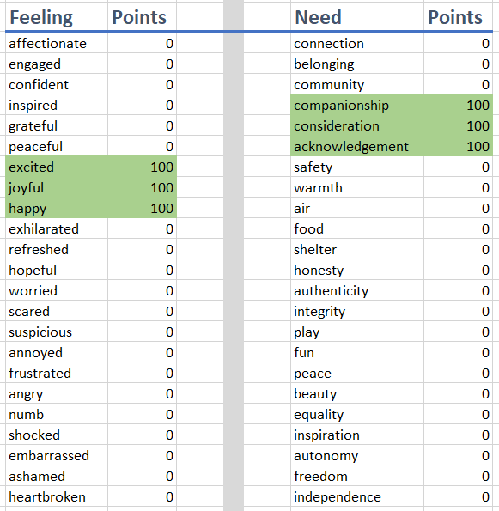

## **Scoring Model #2 - “Needs a little empathy”(Medium)**

In this model you will need to identify more than one feeling/need in order to collect points.

* Picking any correct feeling/need gives partial points. (e.g. 35 points) Once you have collected over 100 points, you get to move to the next stage.
* Picking an incorrect feeling/need has no impact on your score
* *Optional: system may offer a clue after X number of incorrect feeling/need guesses*
* *Optional: system to automatically move on to the next stage after Y number of guesses*

Picking several feeling/need in green will give you the 100 points necessary for the next stage.   
ONLY PICK ON EMOTION AT A TIME, because it is hard to parse 2 emotions

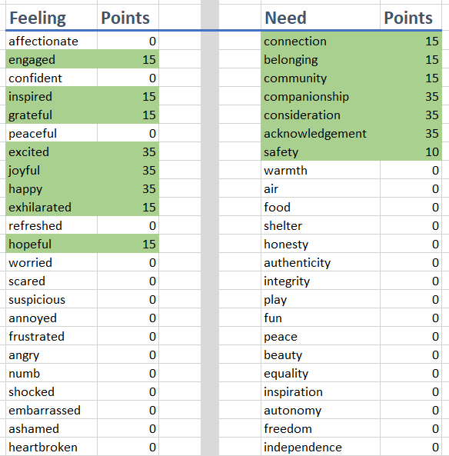

## 

## Scoring Model #3 - “Emotionally fragile” (Hard)

In this model you will need to identify more than one feeling/need in order to collect points. Picking an incorrect feeling/need will subtract points, which require you to spend more time validating emotions

* Picking any correct feeling/need gives partial points. (e.g. 35 points) Once you have collected over 100 points, you get to move to the next stage.
* Picking an incorrect feeling/need has impact on your score (e.g. -25 points)
* *Optional: system may offer a clue after X number of incorrect feeling/need guesses*
* *Optional: system to automatically move on to the next stage after Y number of guesses*

Picking several feeling/need in green will give you the 100 points necessary for the next stage.   
ONLY PICK ON EMOTION AT A TIME, because it is hard to parse 2 emotions

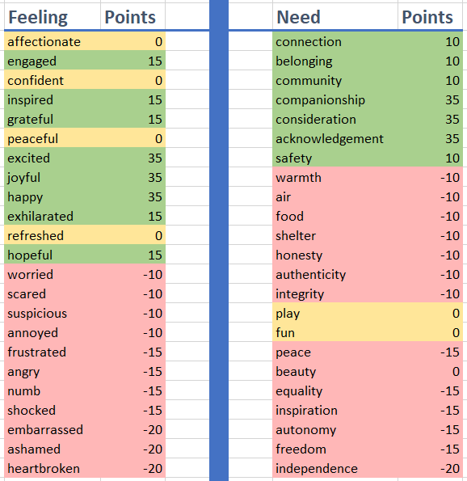

**More scoring is done for each statement also**

Each sentence you type will be analyzed several different ways

1. {'input_response_score': 100} How closely did you identify the correct feeling or need. For example “feeling angry” or “need for peace.” Each practice persona will have 1 or more correct answers for each feeling/need. The other 300+ feeling/need options will be put into small groups based based on their similarity to the correct answer. For example, If the correct feeling was “sad”, if you guessed the feeling words like “dismayed” or “worried”, you would score more points than if you guessed words like “happy” or “joyful”.
   1. Could give negative scores for bad guesses
   2. Could give negative score for too many guesses
2. {'did_it_sound_like_nvc': (0.58119, 0.41881)} Did the sentence sound like NVC? (likely lositive, likely negative) For example, “are you feeling…” or “It seems like your need for …” This is based on a large dictionary of the usual ways of saying things in NVC. This dictionary grows over time. This is based on a trained chatbot analysis
3. {'input_polarity': 0.45}Polarity measures emotional intensity. Negative emotion<-> rational<->positive emotion. Your responses should not be too strongly negative or positive, but it can depend on the correct feeling/need.
4. {'input_subjectivity': 1.0} Subjectivity measures if the sentence declares a fact or declares an opinion. Generally, your sentences should tend to be more of a declaration of opinion, rather than a strong statement of fact. NLTK out of the box.
5. ...more scoring methods to be created

Two kinds of scores are collected for each input

* **User_input_response_score**s - this is the scores on the raw input from the user
* **Cleaned_user_input_response_scores** - this is the scores for the cleaned input from the user. Often times before a statement is analyzed by a machine the input will be cleaned and transformed to make it easier to understand for the computer. Examples of transformations might be fixing spelling mistakes, removing unnecessary white space, converting word to their root form, removing common words or duplicate words,...

It was important to capture the raw and the cleaned input so we can later evaluate cleaning methods

Each response is evaluated by 4 metrics and stored in the logs.

{'input_response_score': 100}

{'did_it_sound_like_nvc': (0.58119, 0.41881)},

{'input_polarity': 0.45},

{'input_subjectivity': 1.0},

Totals are calculated in the app, but totals are not saved to the logs. It is reasoned that totals can be calculated later if needed from the data in the logs, so it does not need to be stored

**The format for each row of the logs is:**

**timestamp, topic, data**

Example 2021_04_18_21_14_49 , user_input_response_scores , {'rating_nvc',(0.58119, 0.418 ...

The session data is kept in logs per session. Like this:

2021_04_18_21_14_49 , cleaned_user_input , {'cleaned_user_input': "['hello']"}

2021_04_18_21_14_49 , cleaned_user_input_response_scores , {'did_it_sound_like_nvc', (0.58119, 0.41881)}, {0.0, 'input_polarity'}, {0.0, 'input_subjectivity'}, {'input_response_score', 50}

2021_04_18_21_15_02 , user_input , {'user_input': 'how are you today'}

2021_04_18_21_15_02 , user_input_response_scores , {'did_it_sound_like_nvc': (0.58119, 0.41881)}, {'input_polarity': 0.0}, {'input_subjectivity': 0.0}, {'input_response_score': 100}

2021_04_18_21_15_02 , cleaned_user_input , {'cleaned_user_input': "['how', 'are', 'you', 'today']"}

2021_04_18_21_15_02 , cleaned_user_input_response_scores , {'did_it_sound_like_nvc', (0.58119, 0.41881)}, {0.0, 'input_polarity'}, {0.0, 'input_subjectivity'}, {'input_response_score', 100}

2021_04_18_21_15_22 , user_input , {'user_input': 'are you feeling sad'}

2021_04_18_21_15_22 , user_input_response_scores , {'did_it_sound_like_nvc': (0.78886, 0.21114)}, {'input_polarity': -0.5}, {'input_subjectivity': 1.0}, {'input_response_score': -5}

2021_04_18_21_15_22 , cleaned_user_input , {'cleaned_user_input': "['sad']"}

2021_04_18_21_15_22 , cleaned_user_input_response_scores , {'did_it_sound_like_nvc', (0.58119, 0.41881)}, {-0.5, 'input_polarity'}, {1.0, 'input_subjectivity'}, {'input_response_score', -5}

2021_04_18_21_15_32 , user_input , {'user_input': 'nvc feelings'}

2021_04_18_21_15_32 , user_input_response_scores , {'did_it_sound_like_nvc': (0.78886, 0.21114)}, {'input_polarity': 0.0}, {'input_subjectivity': 0.0}, {'input_response_score': 0}

## 

# **Persona Development Guide**

This section details how to use the software.

## **A persona is defined in a Google Sheet.**

In this person file each conversational unit is it’s own worksheet in the spreadsheet

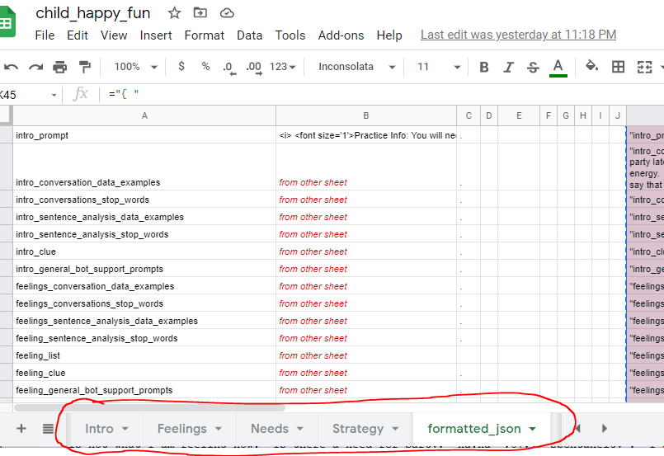



The tab ‘**formatted_json**’ collects the inputs from all the pages and presents them as valid json. Copying the content of column ‘K’, paste into a text document, save as json.

The ‘feeling’ conversational unit would have the standard set of dictionary headings

* **xxxx_conversation_data_examples** - This is the main listing of conversation. In the present implementation it is set up with key words and responses. As, ["affectionate", "That is not quite the feeling”] The goal of this data set is to make sure the response is aligned with the inputs.
* **xxxx_conversations_stop_words** - This is used to remove common words from sentences to help improve accuracy on the conversation_data_examples analysis.
* **xxxx_sentence_analysis_data_examples** - These sentences are different and are for checking sentiment. The goal of this data set is to check if the sentence was shaped like NVC.
* **xxxx_sentence_analysis_stop_words** - These are stop words specific to sentiment analysis
* **xxxx_list** - a list of things (feelsing, needs, …) to present to the user on command
* **xxxx__clue** - Not developed yet.. If the user wants a clue, they can get one.

## **Then it is converted to JSON file that the computer reads**

JSON file example

The spreadsheet creates a set of cells that are properly formatted JSON for the data that is needed.

Each worksheet builds the same 6 basic dictionary entries

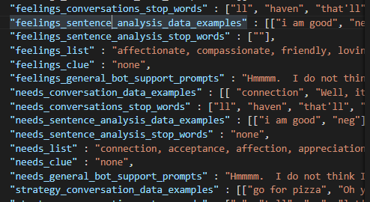

That json looks like

{

**"jackalbot_name"** : "frustrated_and_hungry",

**"jackalbot_updated"** : "44303",

**"jackalbot_version"** : "1.1",

**"jackalbot_author"** : "Mike Roberts",

**"jackalbot_chatbot_name"** : "frustrated_and_hungry",

**"jackalbot_hosts"** : ["Jacques","Jacqueline"],

**"intro_prompt"** : "Background: For this persona, imagine that you have just arrived to the city...

**"intro_conversation_data_examples"** : [["how you doing", "Wow, glad you asked. This town sucks. ..

**"intro_conversations_stop_words"** : [""],

**"intro_sentence_analysis_data_examples"**:[["how ya doing","pos"],["how ya do'n","pos"],["how it .

**"intro_general_bot_support_prompts"** : "Hmmmm. I don’t understand what you are trying to say. …\

**"feelings_conversation_data_examples"** : [[ "affectionate", I don't feel very affectionate. hmmm ..

**"feelings_sentence_analysis_data_examples"**: [["i am good","neg"],["are you feeling","pos"],...

**"feelings_list"** : "affectionate, compassionate, friendly, loving, open hearted, sympathetic, ...

**"feelings_clue"** : "none",

**"feelings_general_bot_support_prompts"** : "Hmmmm. I do not understand what you are trying to...

**"needs_conversation_data_examples"** : [[ "connection", "No, I don't feel very connection. hmmm ...

**"needs_conversations_stop_words"** : ["ll", "haven", "that'll", "against", "himself", "his", "all", ...

**"needs_sentence_analysis_data_examples"** : [["i am good", "neg"],["are you feeling", "pos"],..

**"needs_sentence_analysis_stop_words"** : "none",

**"needs_list"** : "connection, acceptance, affection, appreciation, belonging, cooperation, comm

**.*..much more***

}

There are some items in the JSON that are not being used at the moment, but are place holders for expected future development

These are standard chatterbot configurations that may be required later.

"jackalbot_logic_adapters" : "['chatterbot.logic.MathematicalEvaluation','chatterbo.TimeLogicAdapter']",

"jackalbot_chatbot_database_uri" : "'sqlite:///database.sqlite3'",

"jackalbot_read_only" : "TRUE",

"jackalbot_preprocessors" : "['chatterbot.preprocessors.clean_whitespace']",

"jackalbot_statement_comparison_function" : "statement_comparison_function=levenshtein_distance",

Special Commands

Special commands to type

Nvc start or yy - starts the system

Nvc feelings - provides feelings list

Nvc needs - provides needs list

Nvc scores - toggles showing scores on and off

*Nvc end - ends session - pending*

# Application Technical Architecture

Written in python and a flask app. To be deployed on a public cloud

<https://github.com/MikeRobertsIsHappy/jacquelbot_cloud>

I originally started with this tutorial and some elements are similar

<https://www.twilio.com/blog/build-whatsapp-bot-sentiment-analysis-python-twilio>  
*I am NOT using the ngrok part of this tutorial to expose it to the internet.*

I usually develop with VS Code. I work with a virtual environment

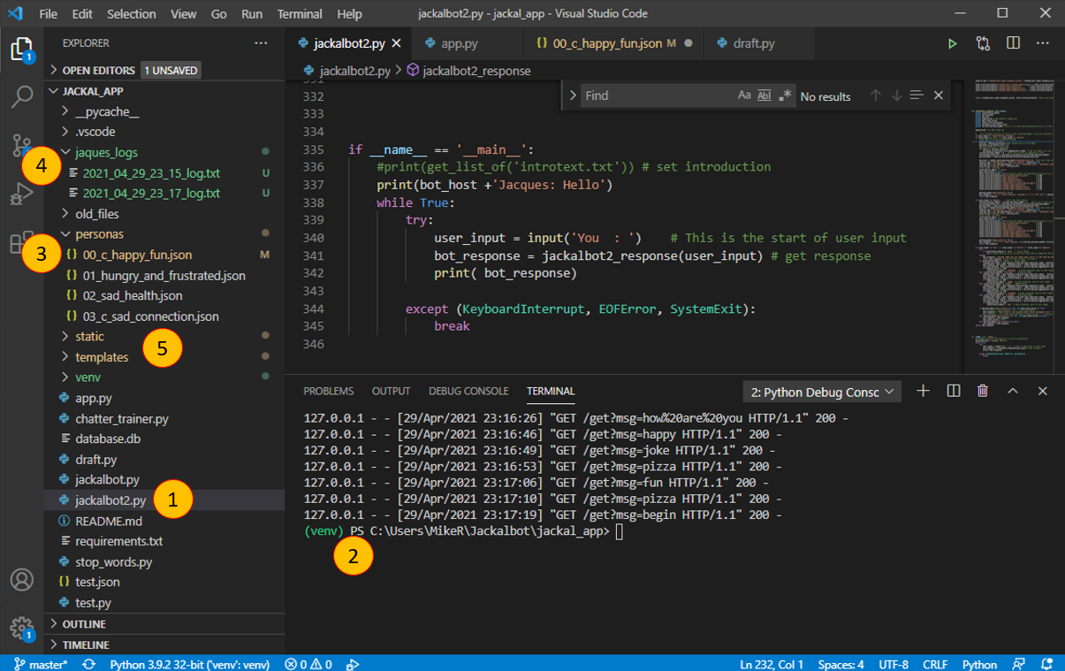

1. main.py is main code base
2. Running in a virtual environment
3. Personas folder - personas are used in alphabetical/numerical order
4. Session logs
5. Static and templates folder contain HTML assets

# **Screenshot of current implementation**

# 

Reference stuff

Jacquelbot image link : <http://clipart-library.com/clipart/499572.htm>